CSE 170 Intro to HCI Assignment 3

* Chuqi Qiu A98032189
* Michael LaPlante A11902093
* Ian Gilmore A10018139
* David Williams A10096980

**Point of View**

Playing games is fun, so is sharing game reviews with others. Users need a way to find games that they’ll enjoy, and a way to share their experiences with others. Game reviews oriented communities and groups can be fun and enjoyable. People can make friends and have their stories heard through the activity of game reviewing. Game reviewing is becoming a new socializing tool, isn’t that cool?!

**Inspiration Board**

Metacritic.com - Collection of critic and user reviews with a focus on critic reviews. However, it can be biased and inaccurate due to focus on critic reviews.

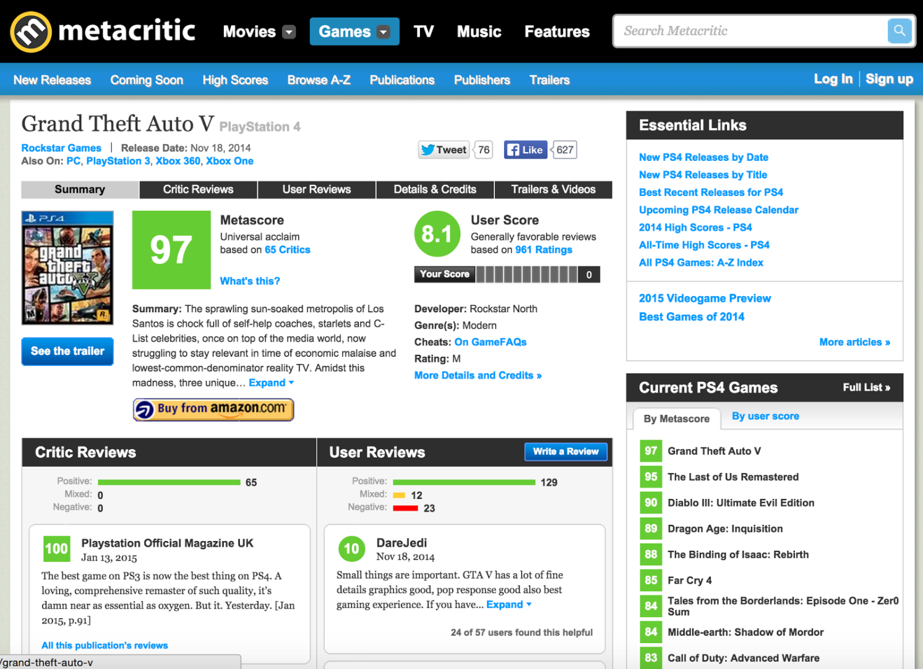

Goodreads.com - Centers on user reviews/rating of books, providing aggregate rating of books based on user reviews, focus is on recommendation, not necessarily user experience.

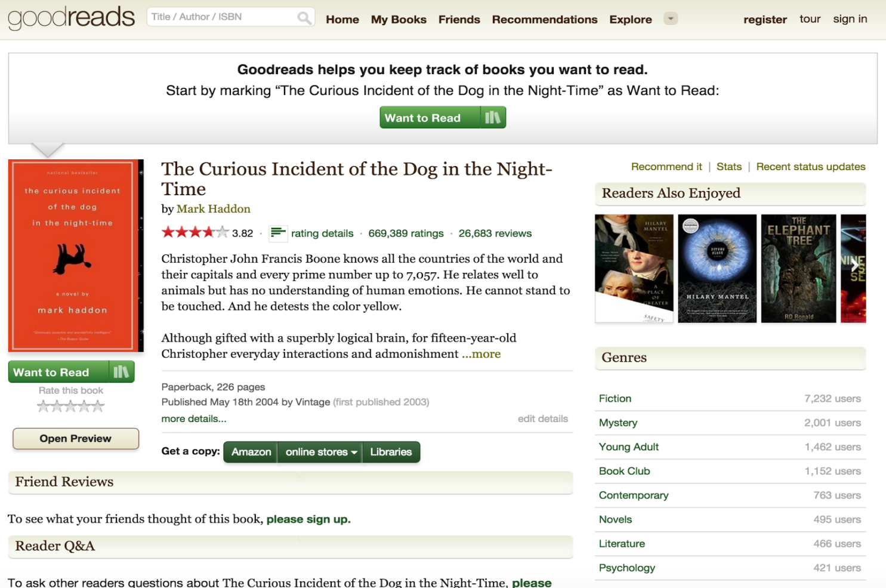

Medium.com - Offers blogging platform/distribution network for aspiring bloggers/writers - mix of images/text in articles not offered in other blogging platforms.

Twitch.tv - Community driven gameplay. Good example of strong community and sharing games across a platform. There is an option to subscribe/support channels.

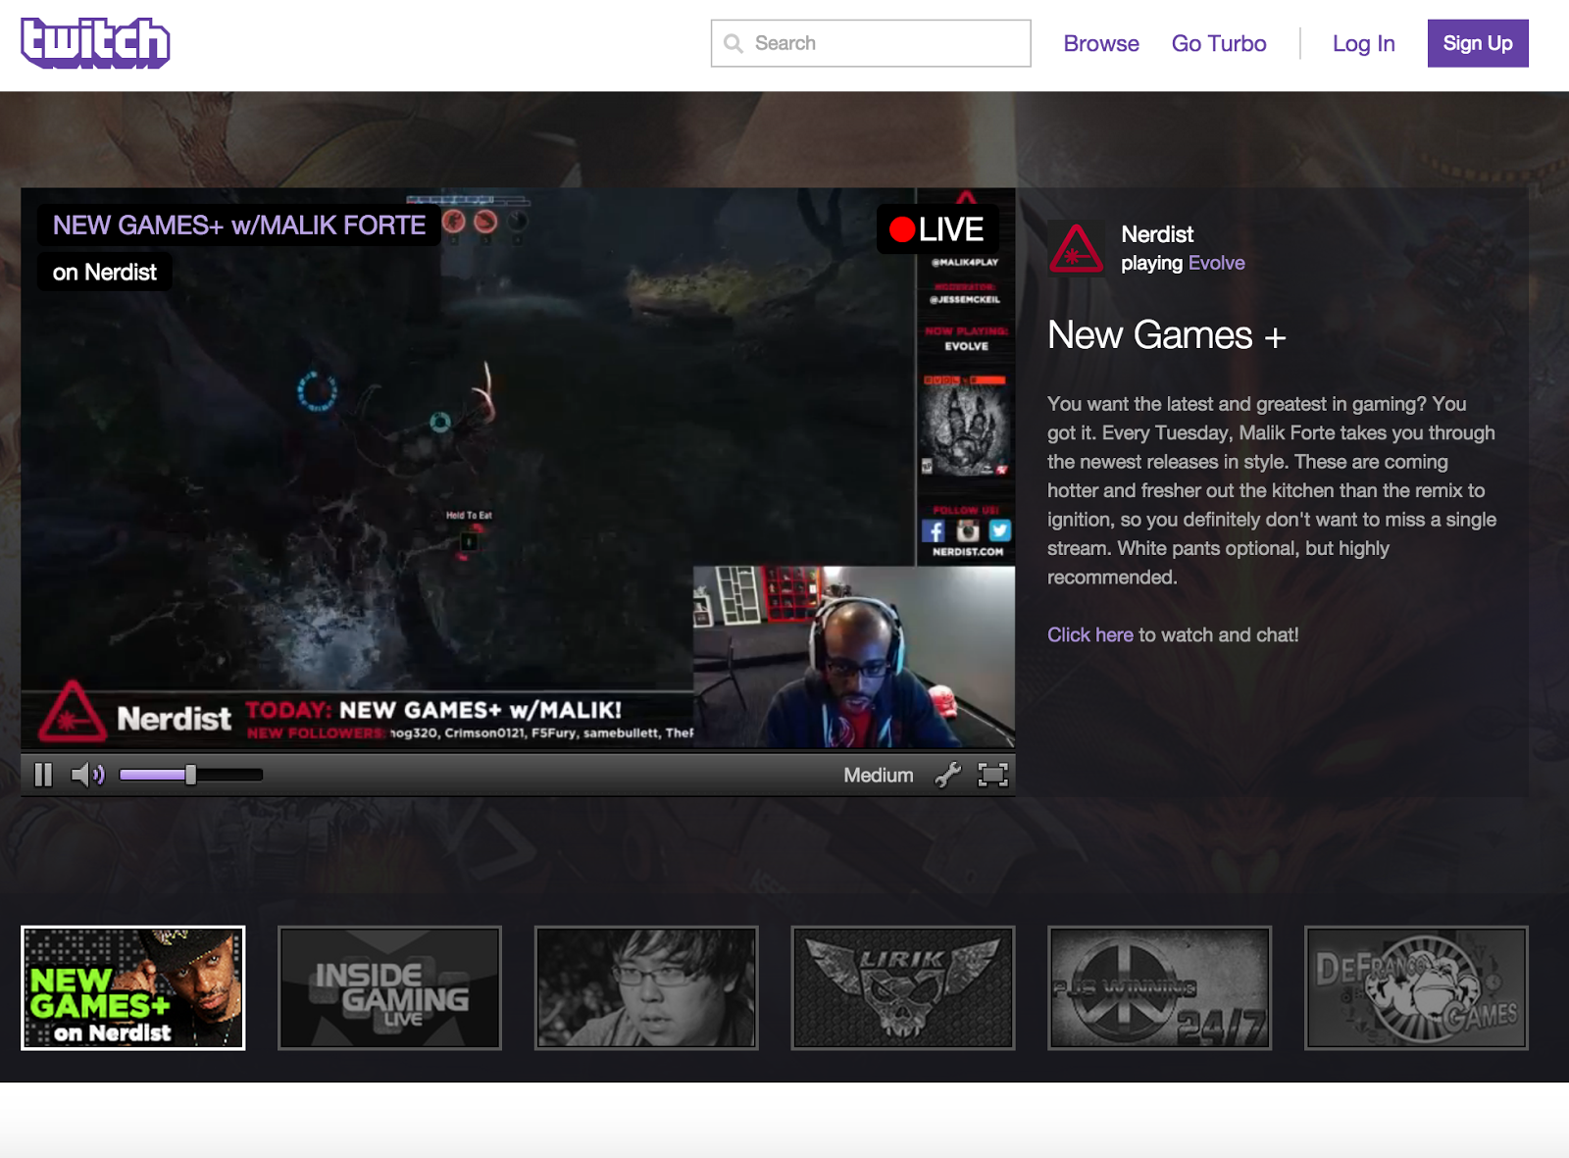

Facebook - Social media sites that allow people to express their feelings or experiences with their friends.

YouTube - Where you can upload and share videos about your own game playing experiences with other players. There is also option to subscribe to channels.

**Key words of inspiration**

We came up with several key words that describe our project and ideas, they are:

**Video games; unbiased; decentralization/democratization;**

**Community; experiences; sharing; discovery; exposure; flexibility**

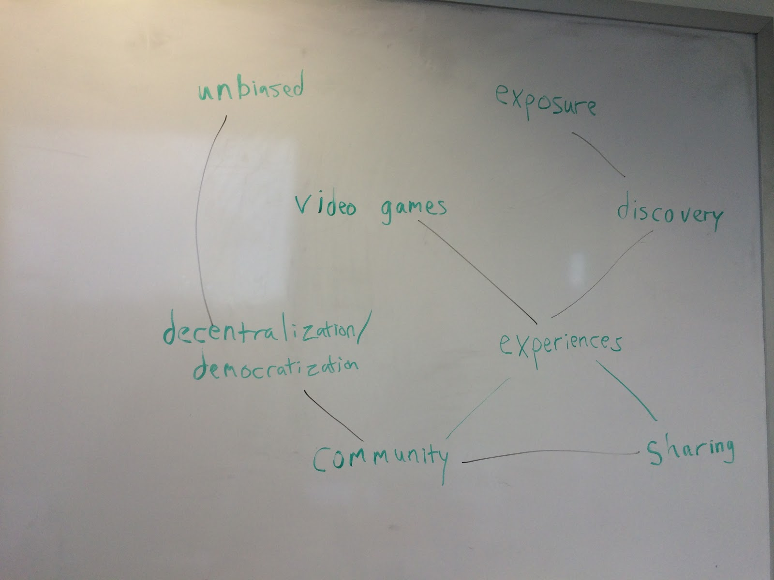

**Storyboarding**

**Story Board #1**

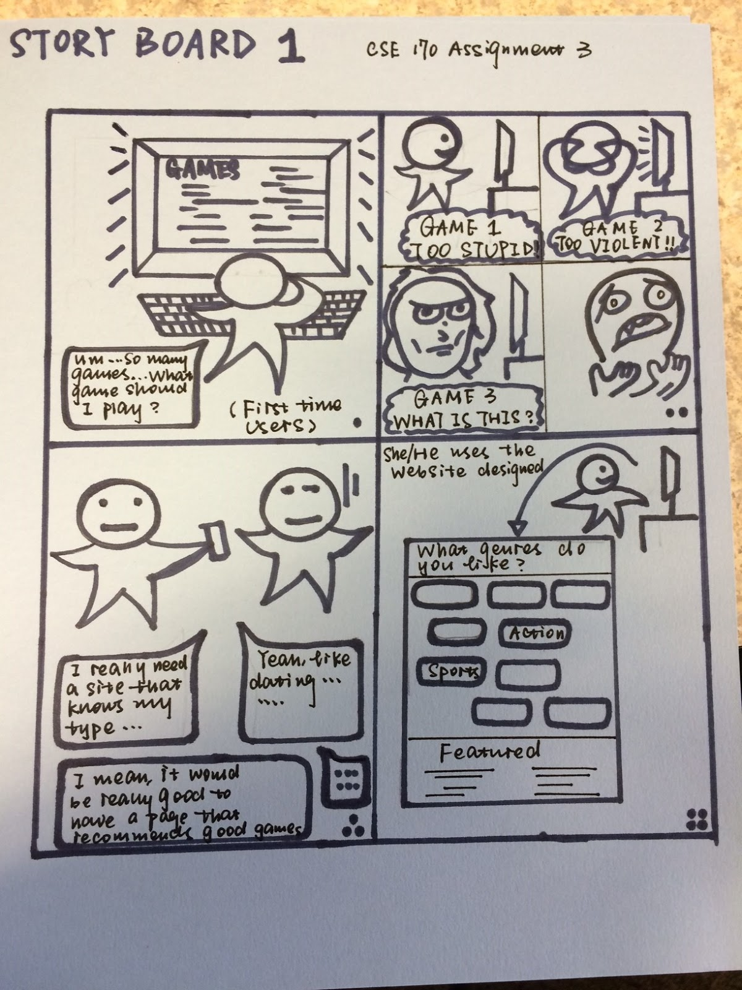

**Story Board**

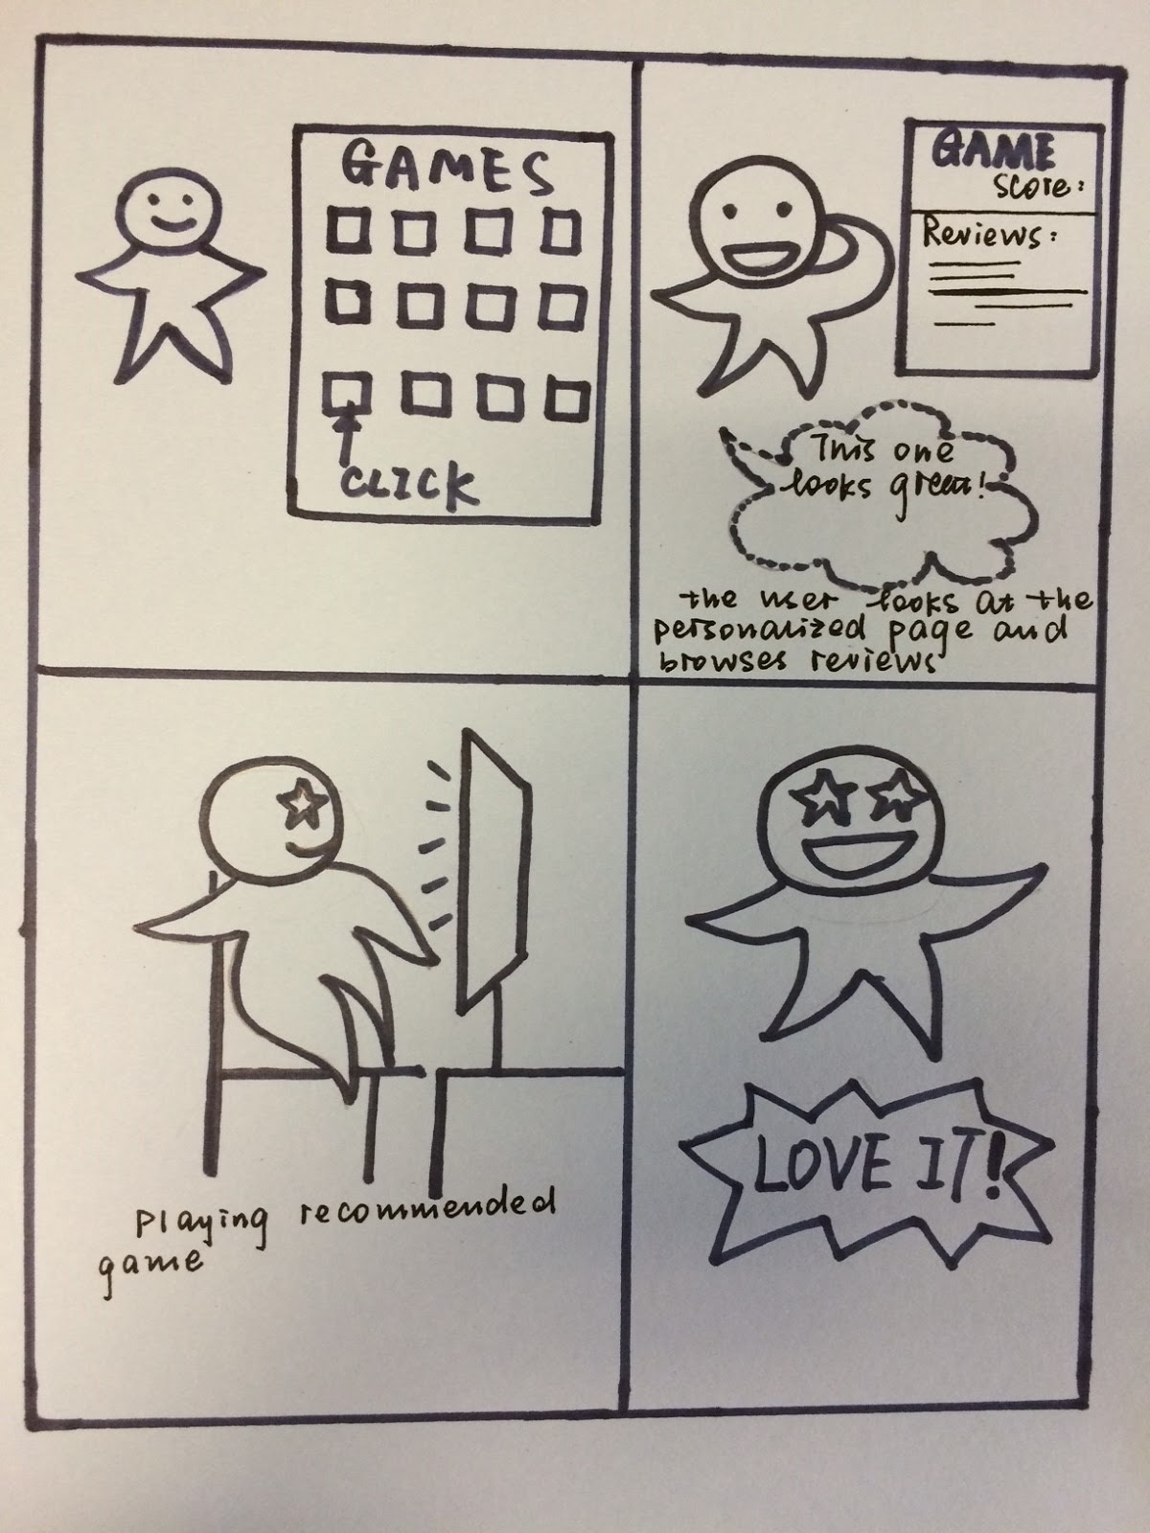**Storyboard #1 Continued**

**Storyboard #2**

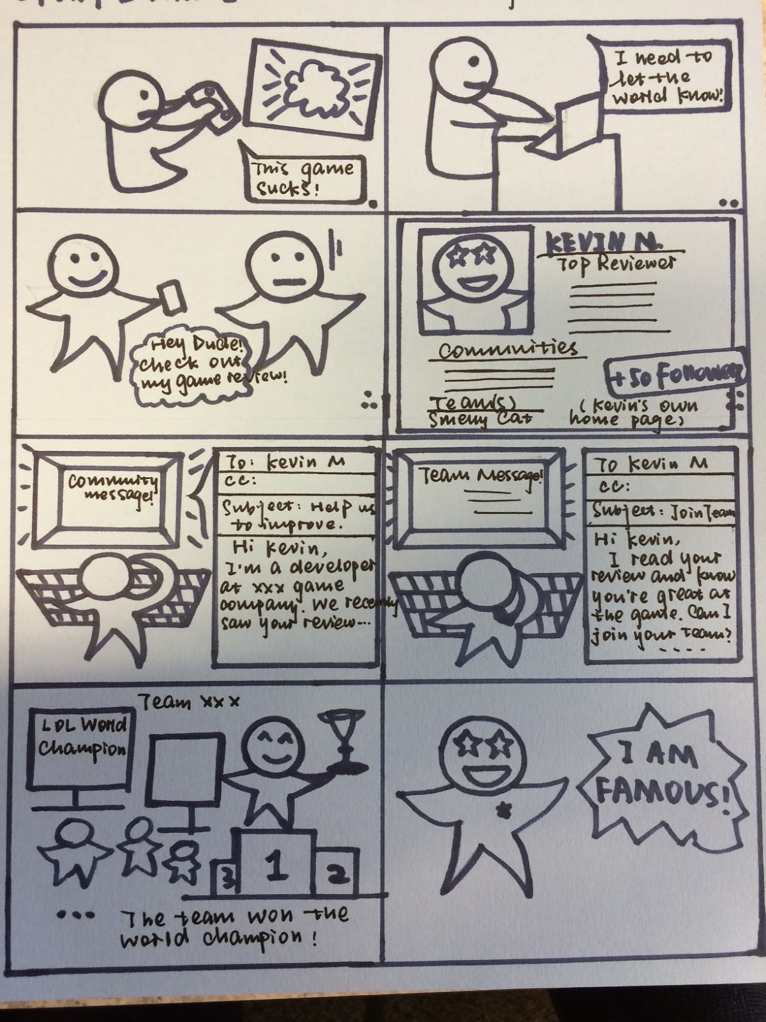

**Prototype**

**Prototype #1**

**All the banners we have ☺**

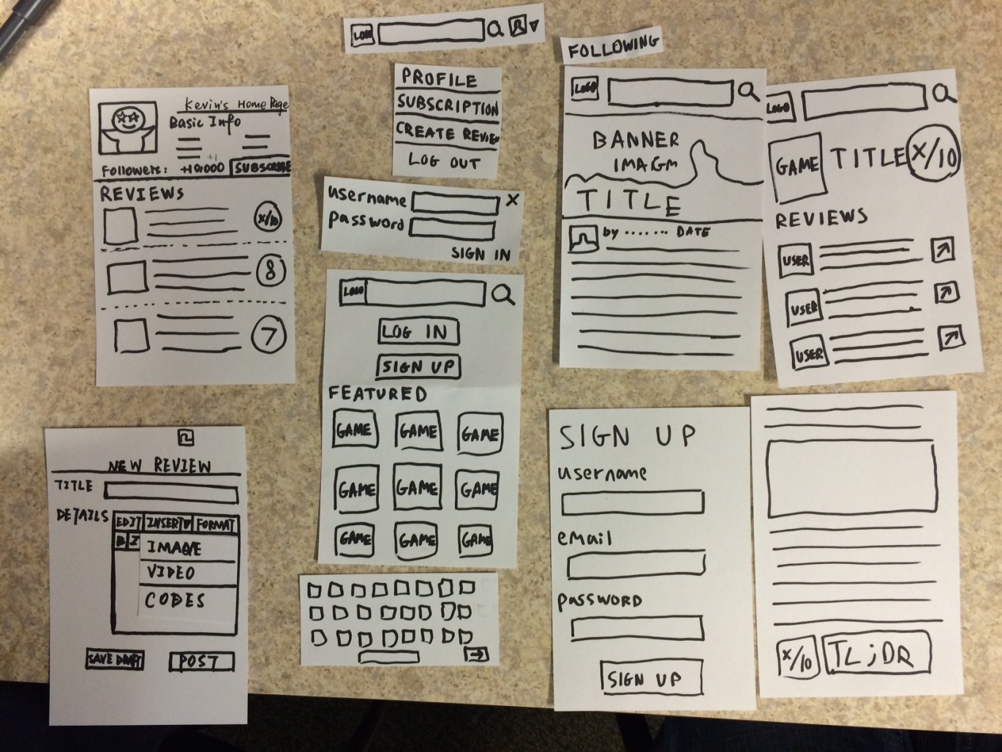

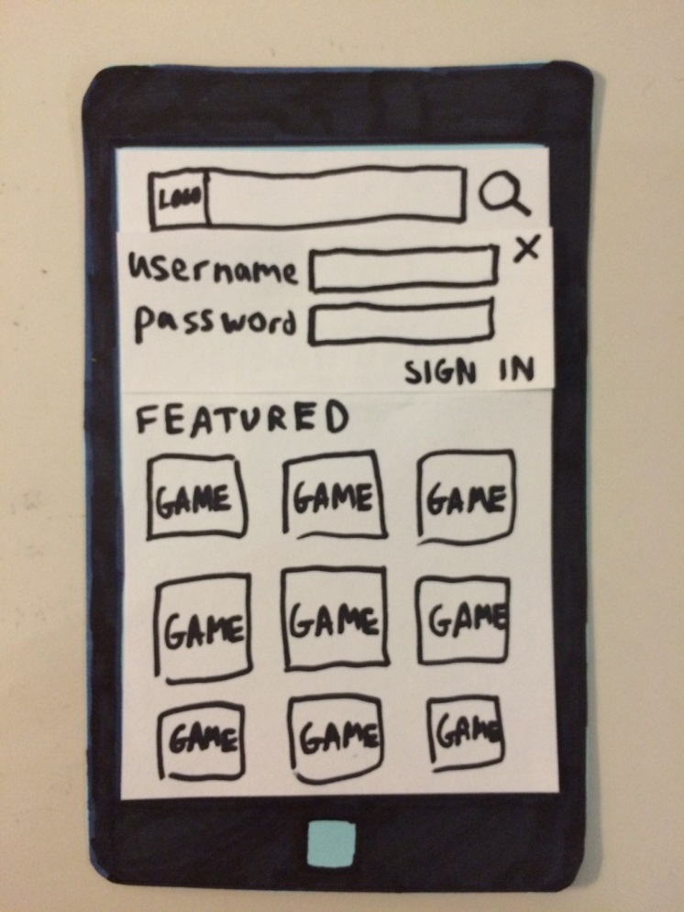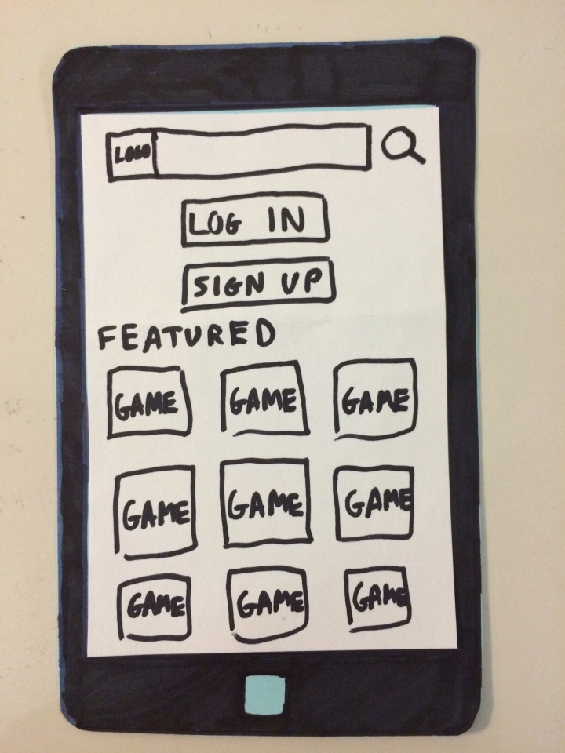**User Flow**

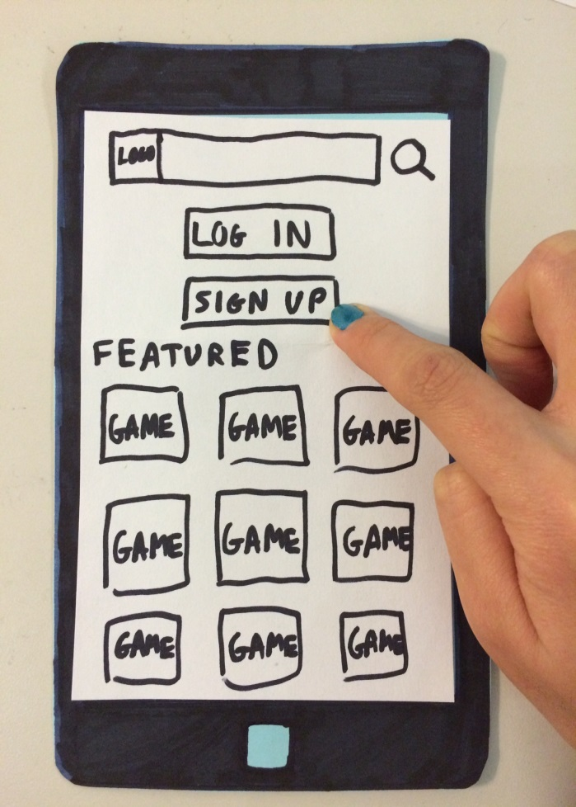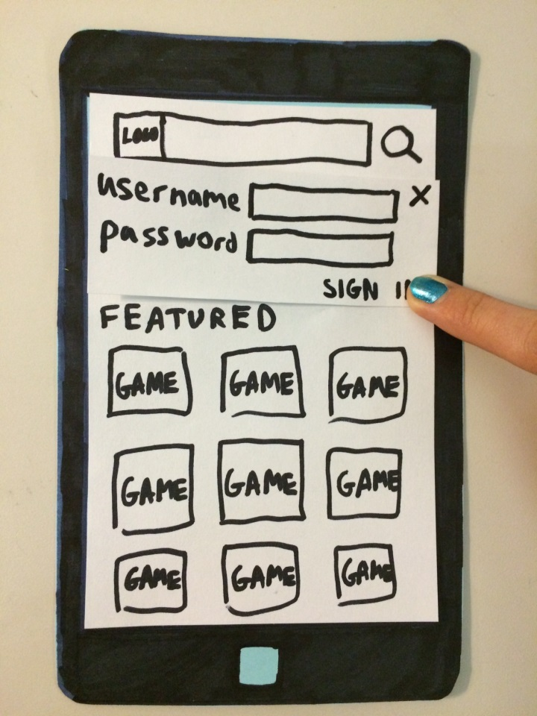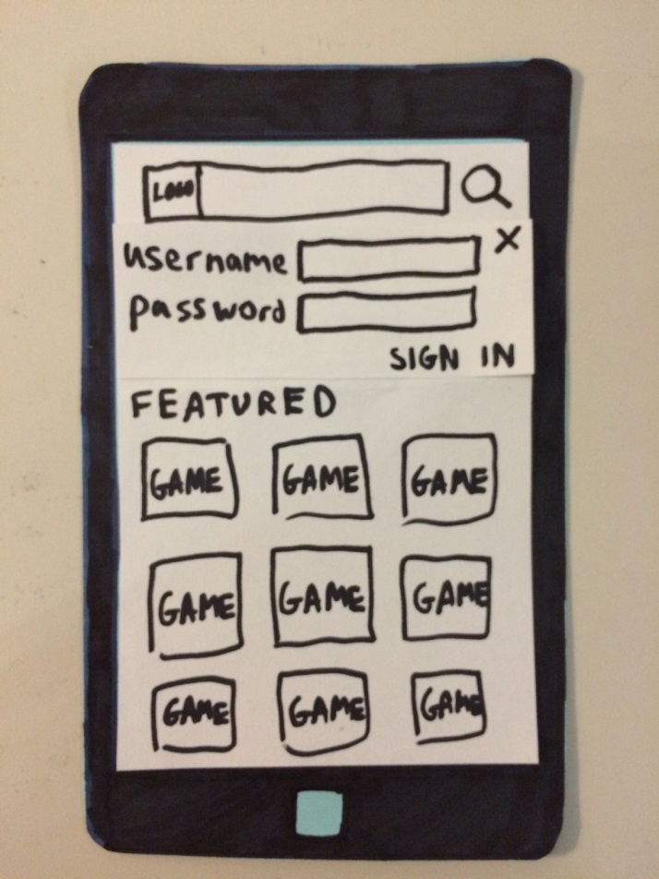

🡺

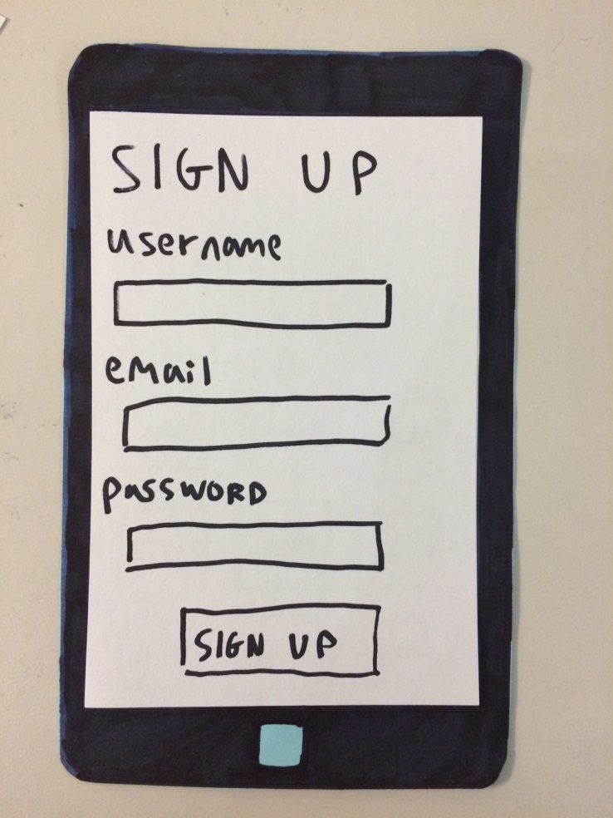

🡺

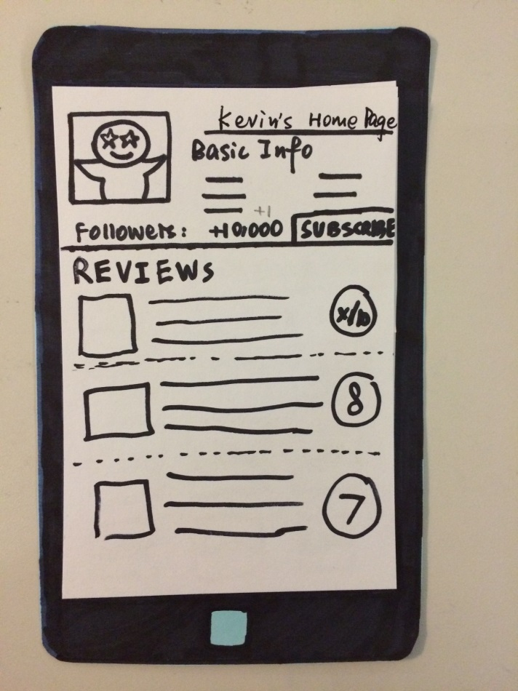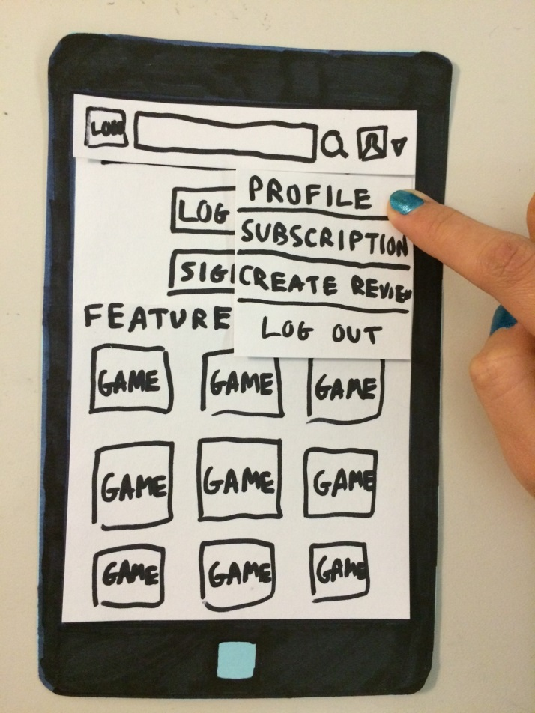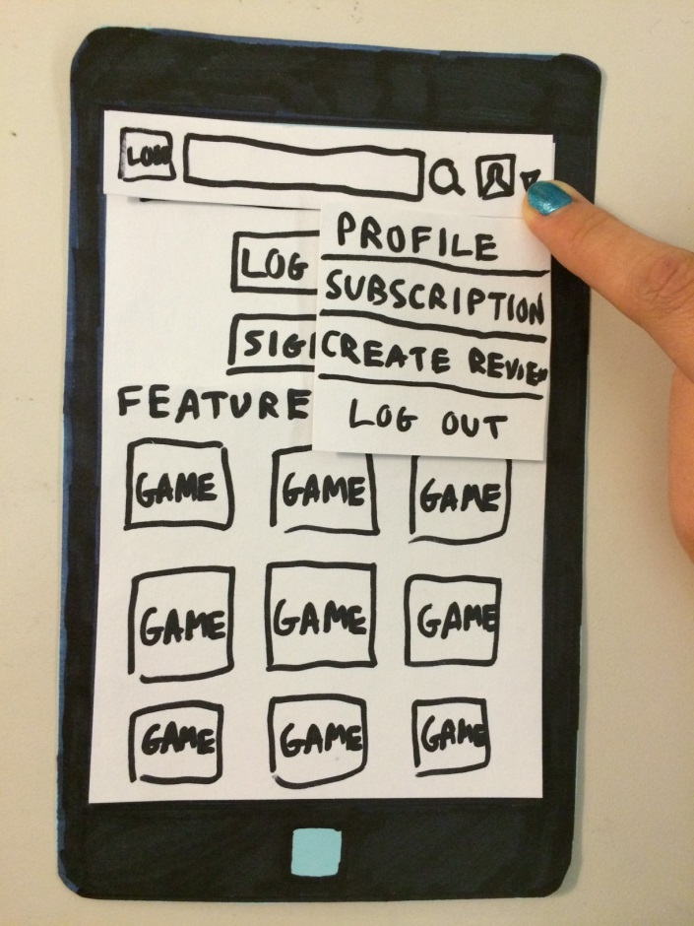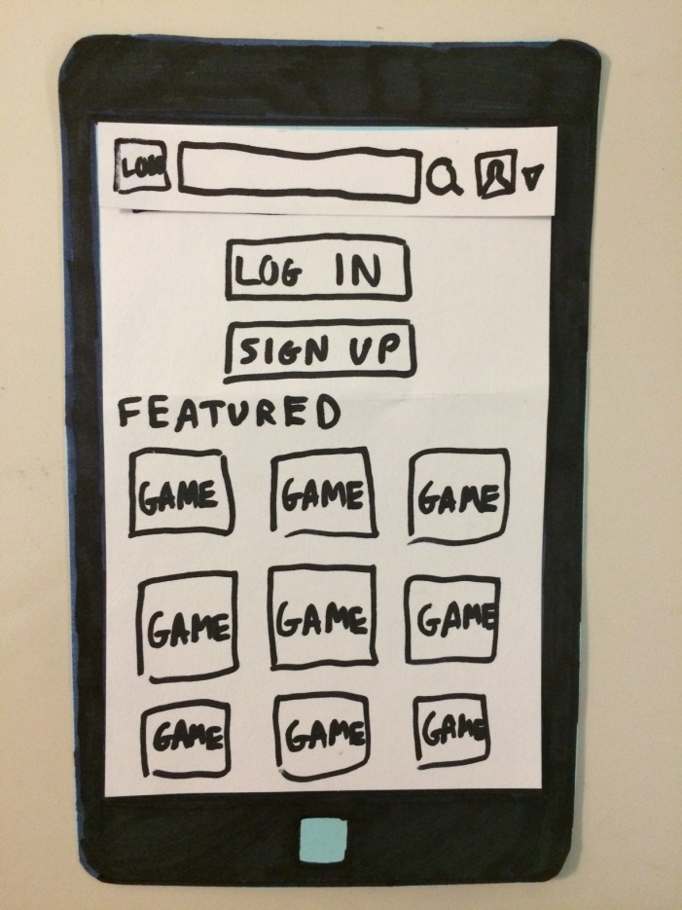

🡺

🡺

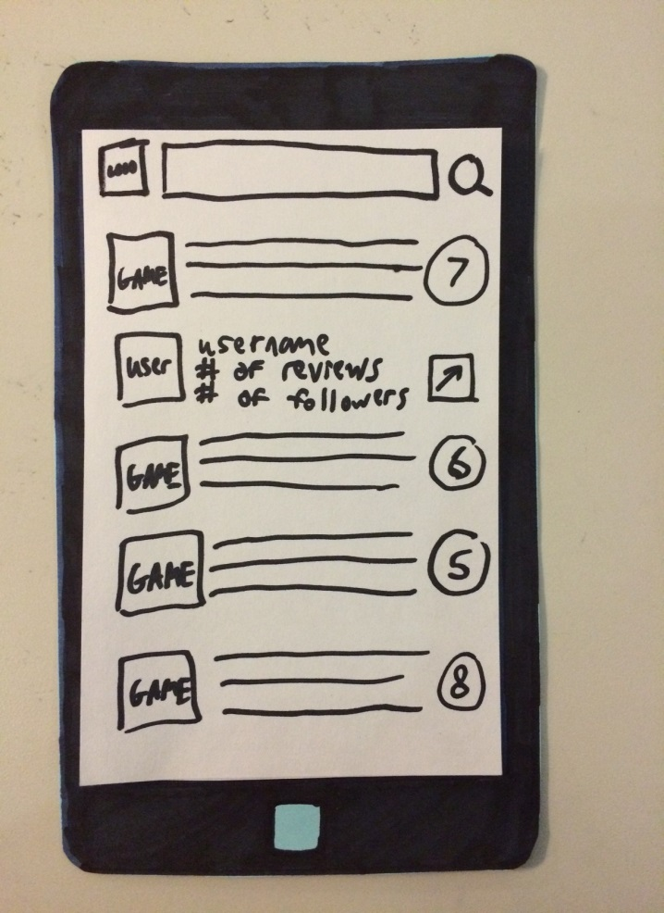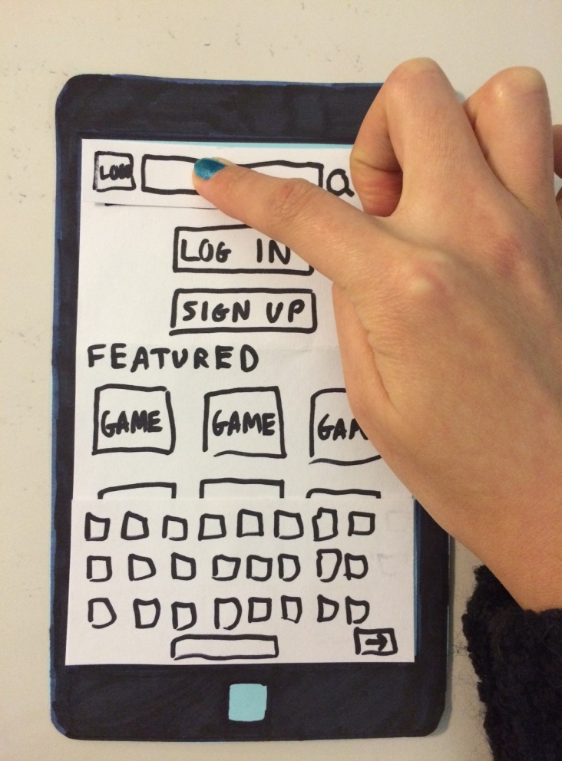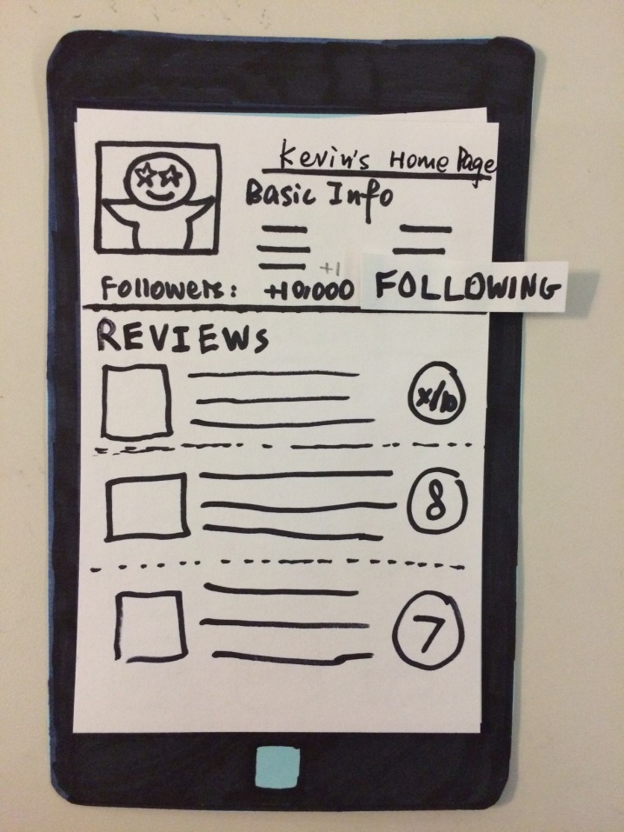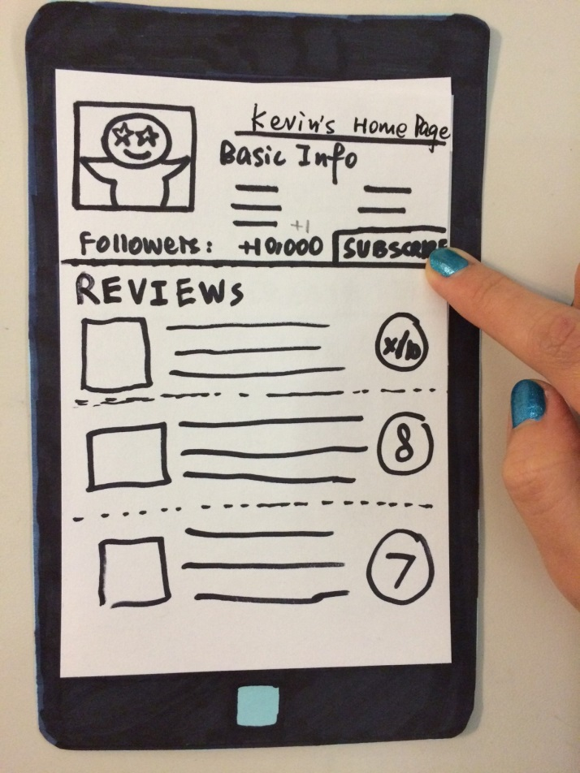

🡺

🡺

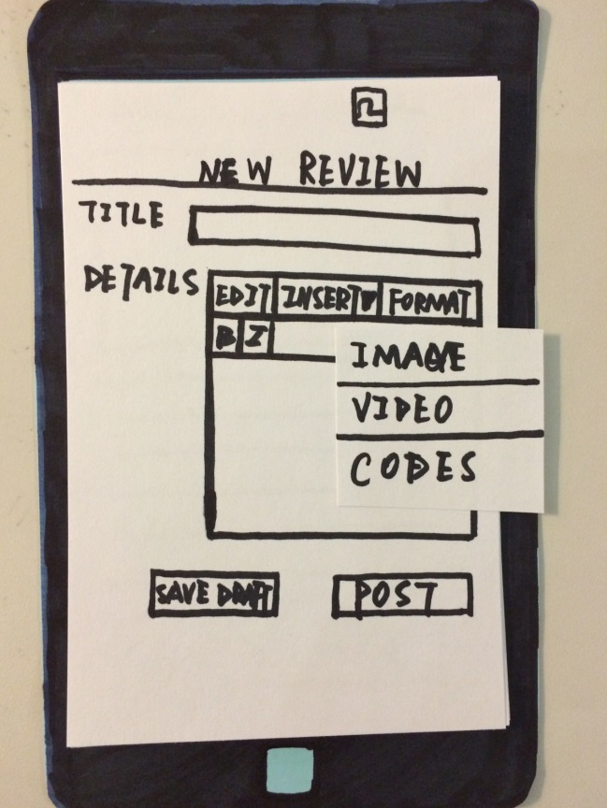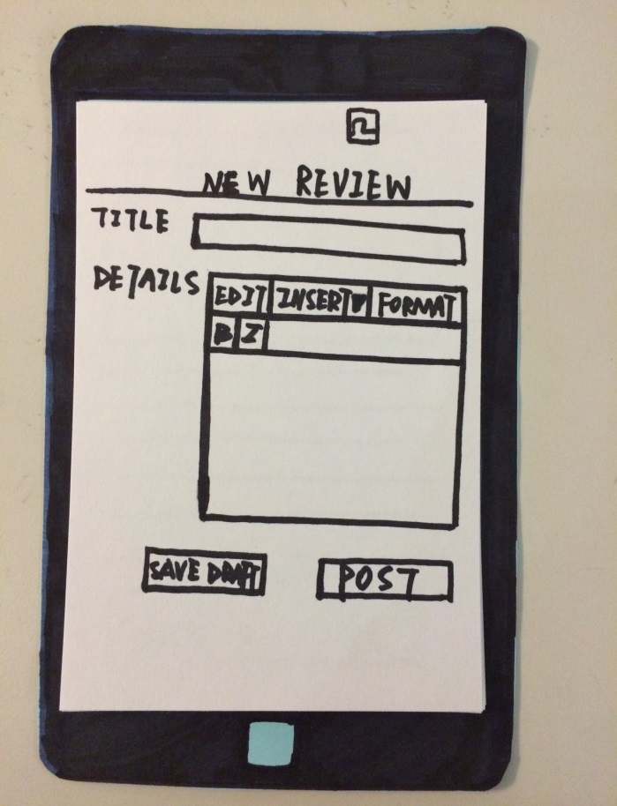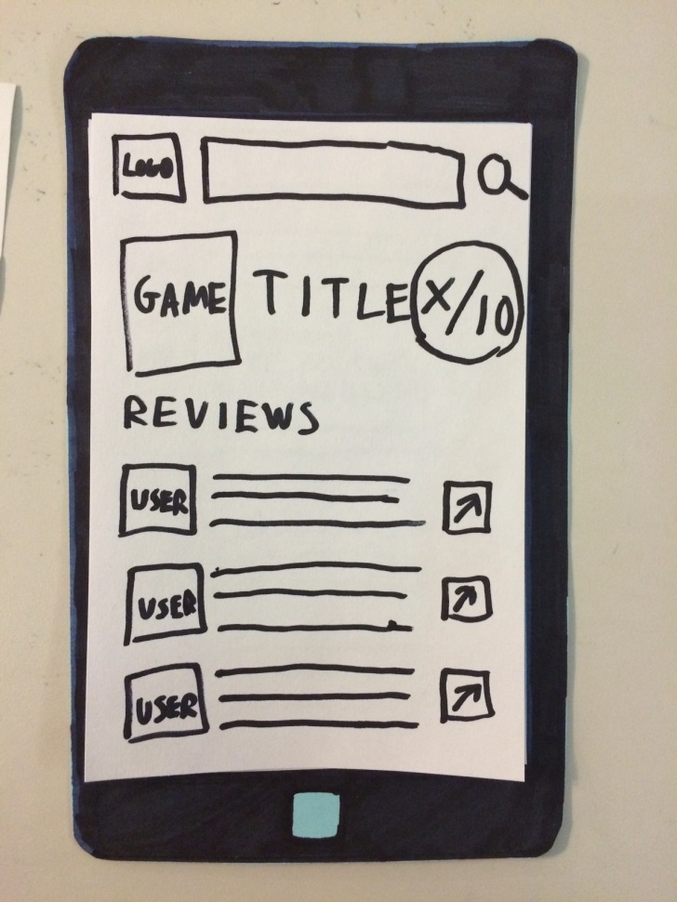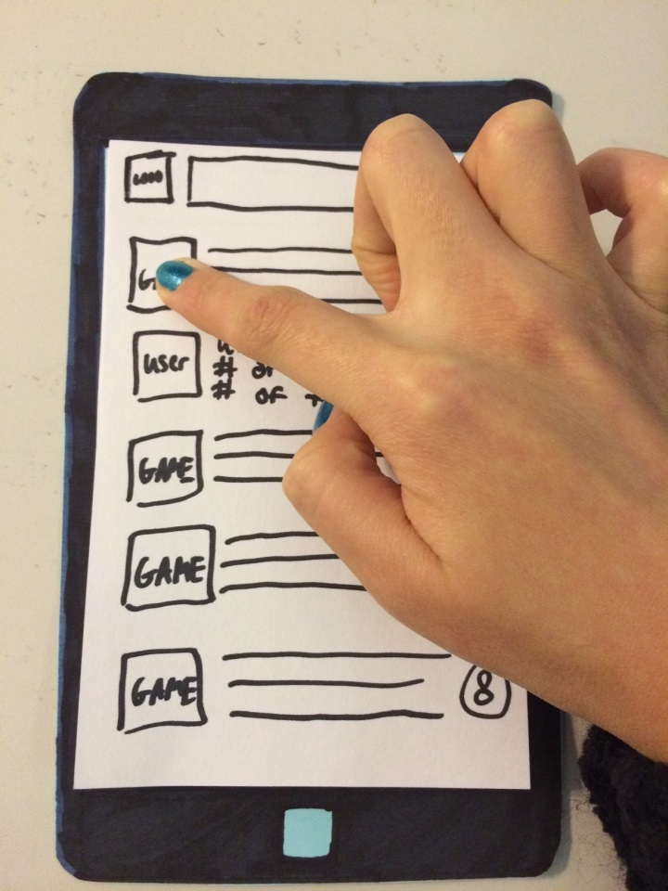

🡺

🡺

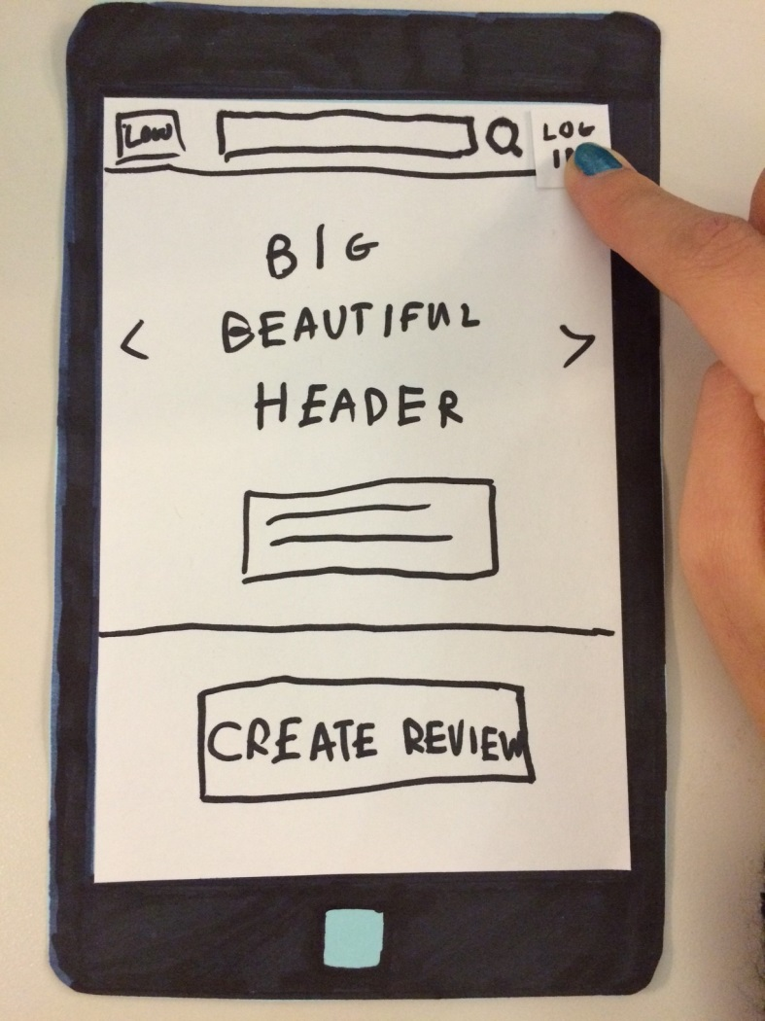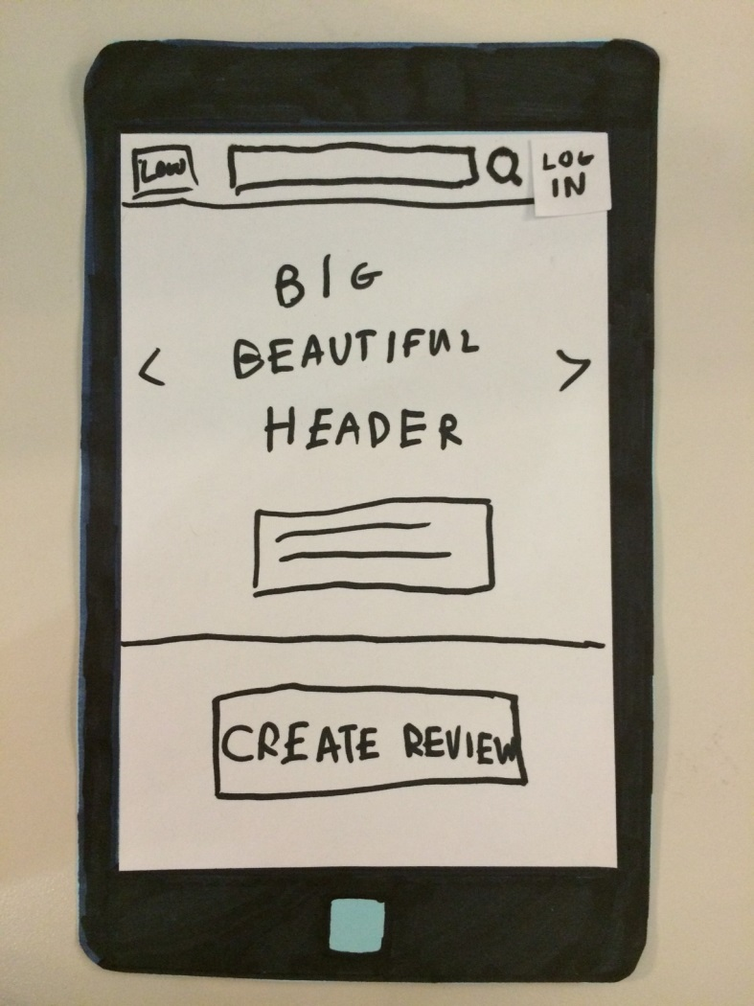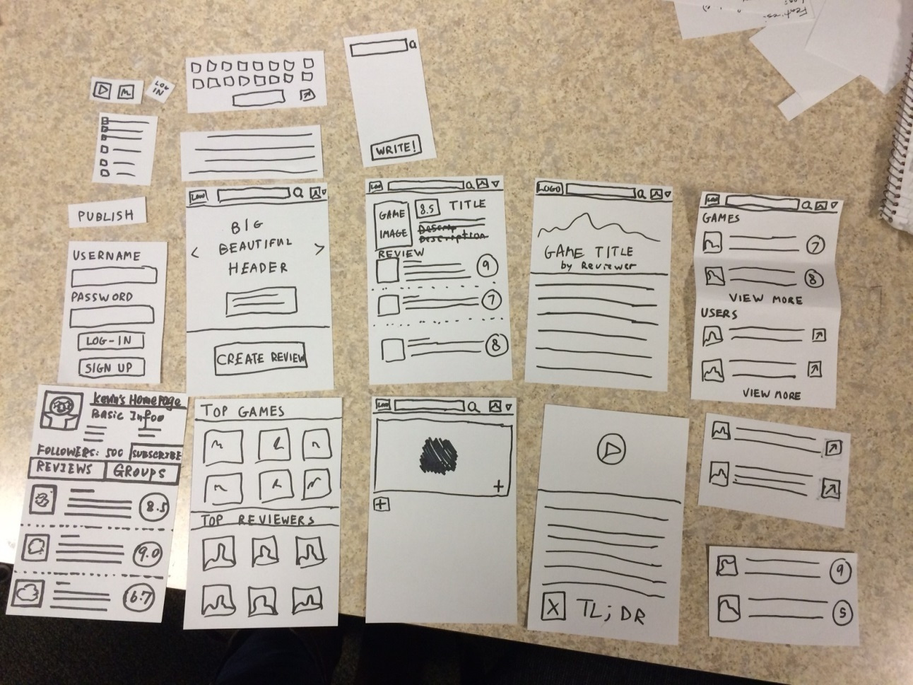**Prototype #2**

🡺

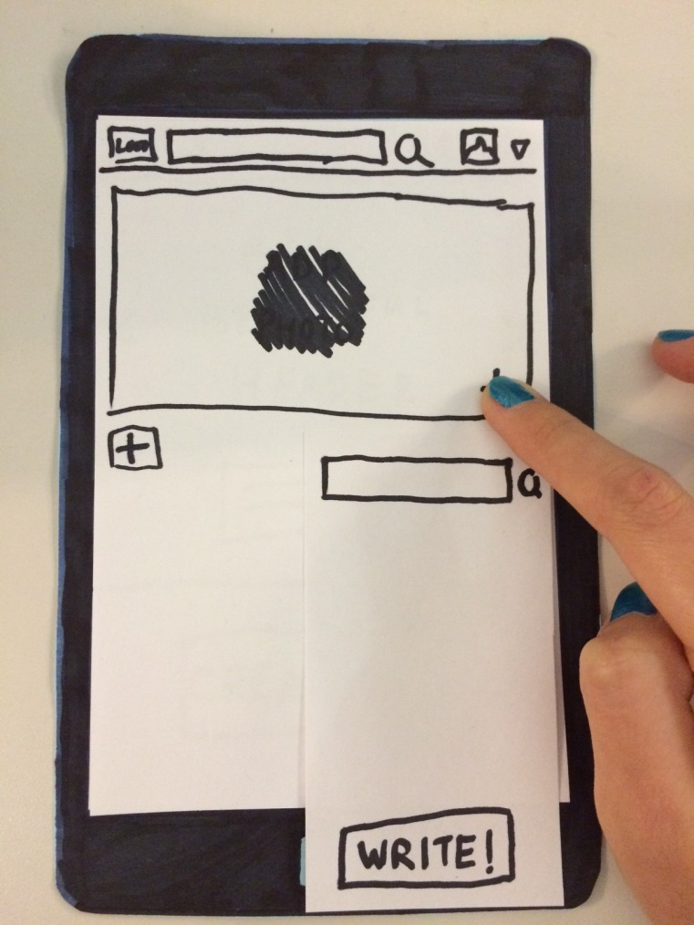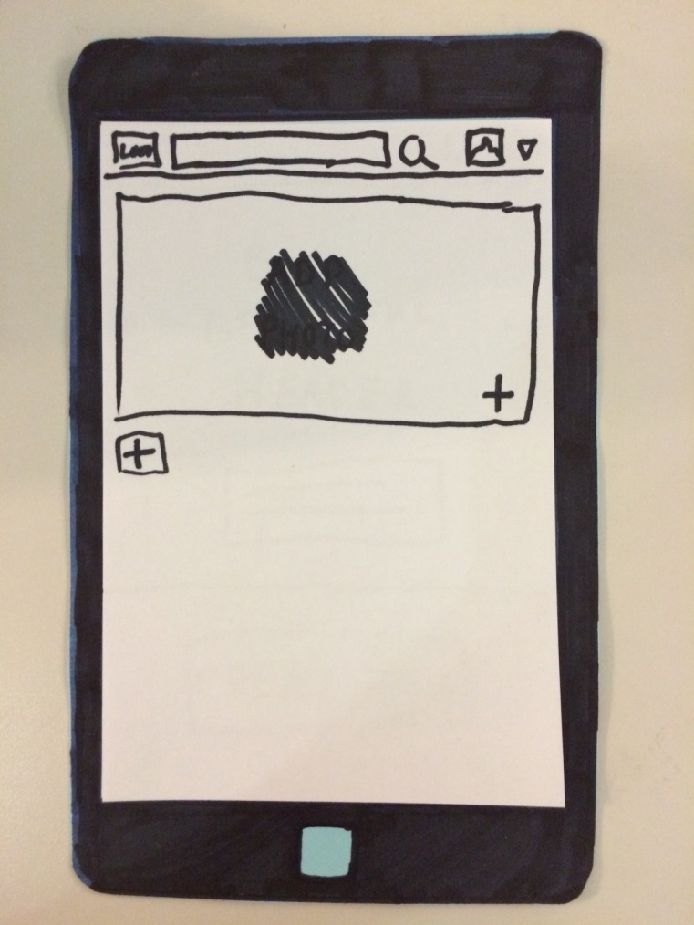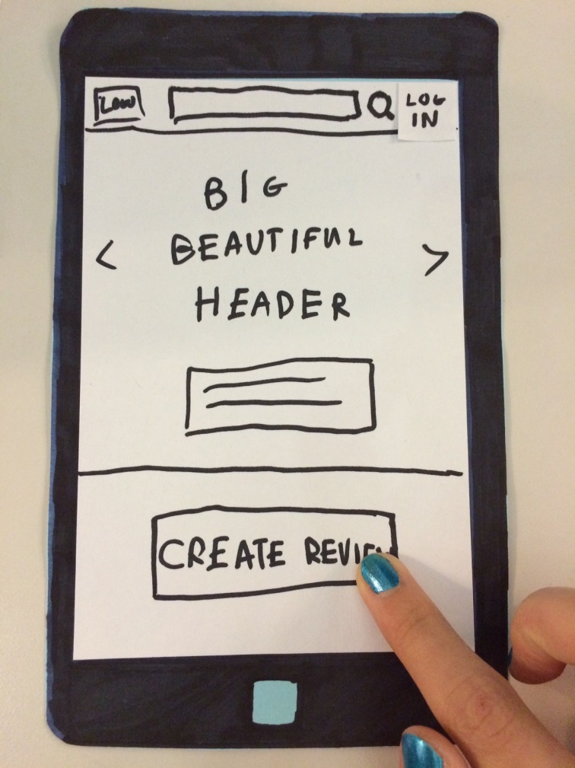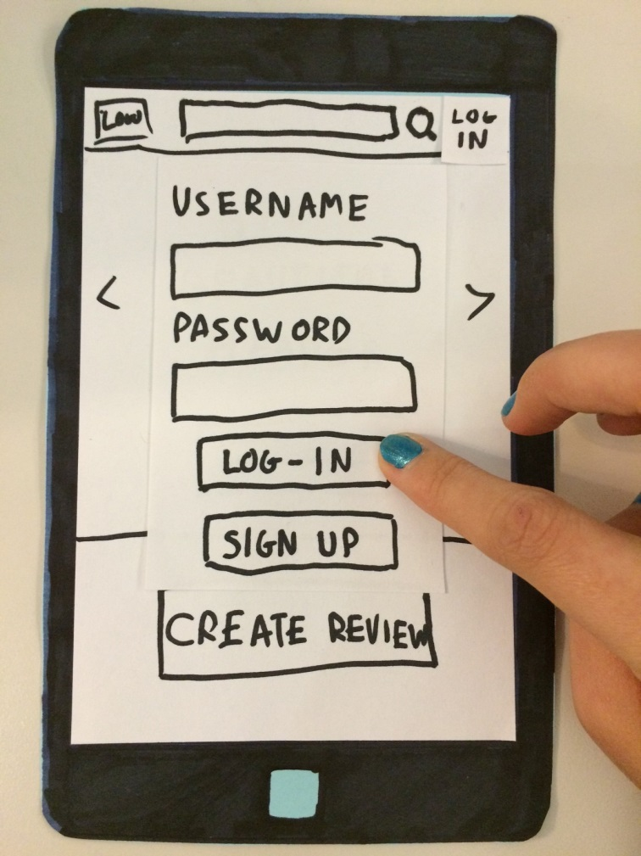

🡺

🡺

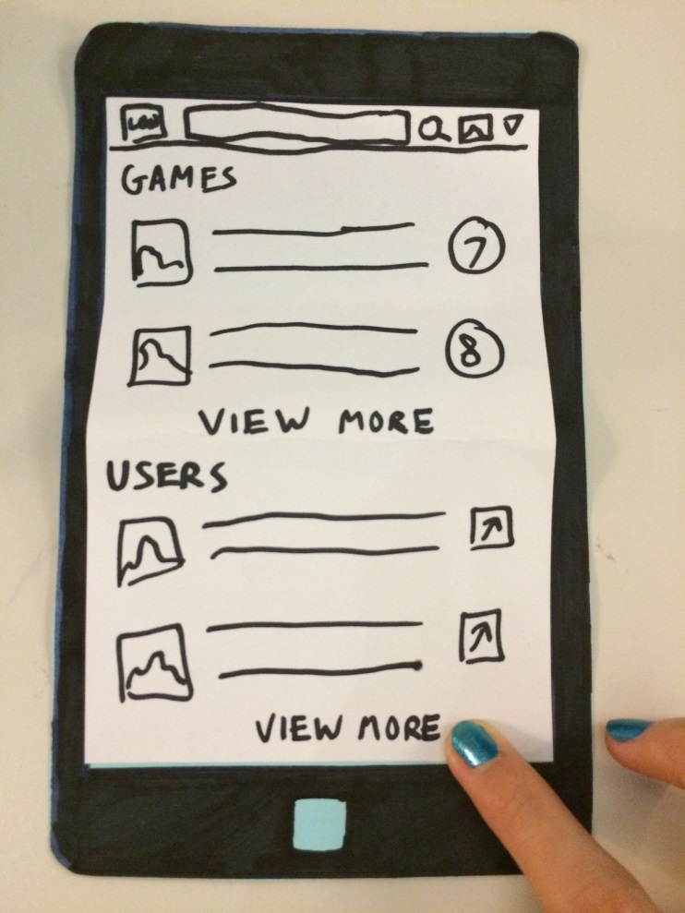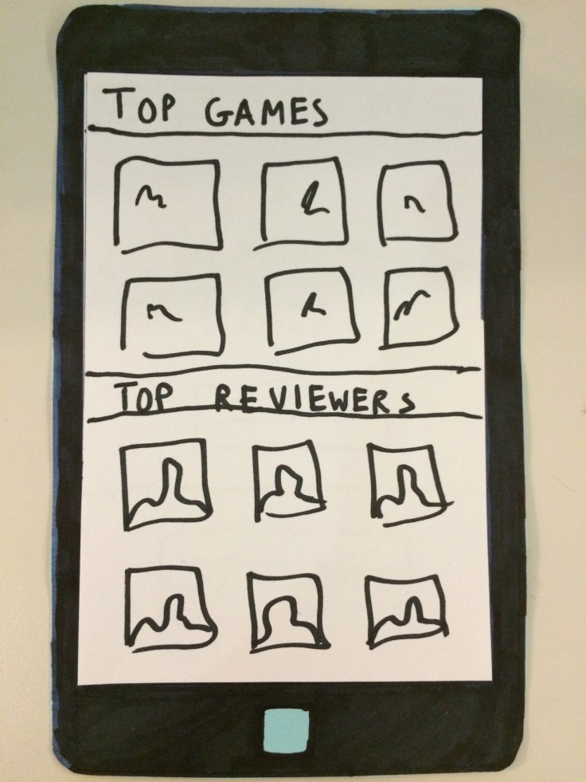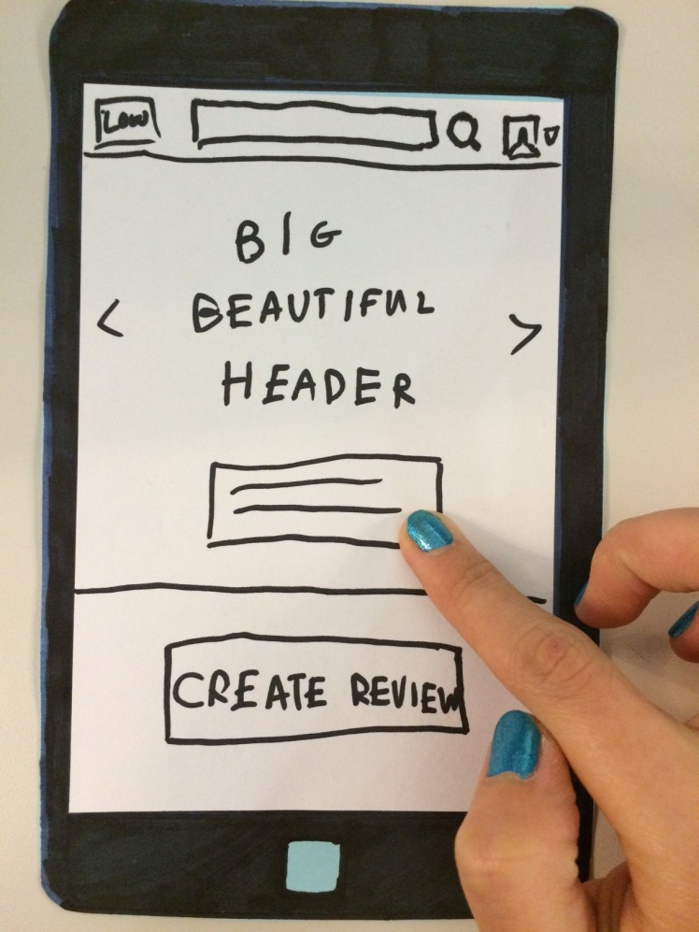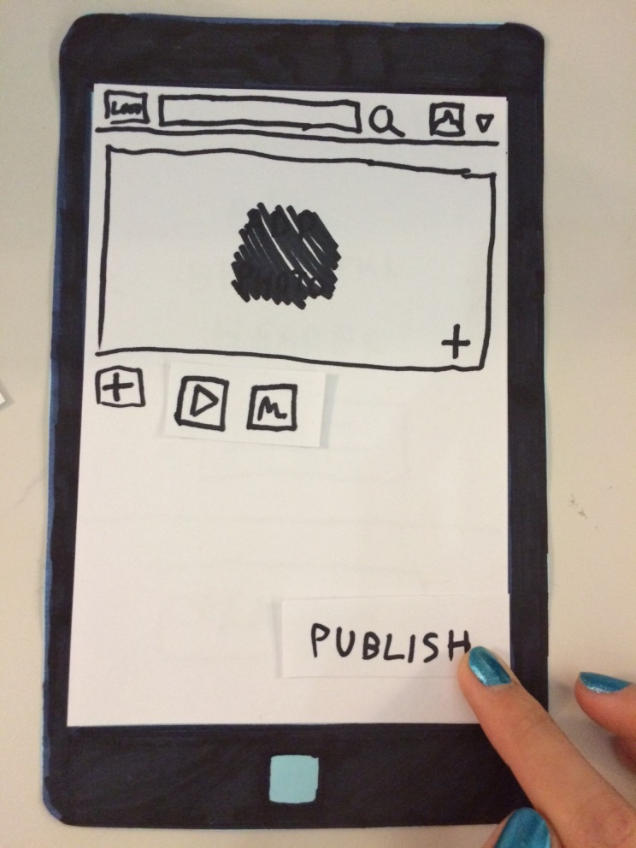

🡺

🡺

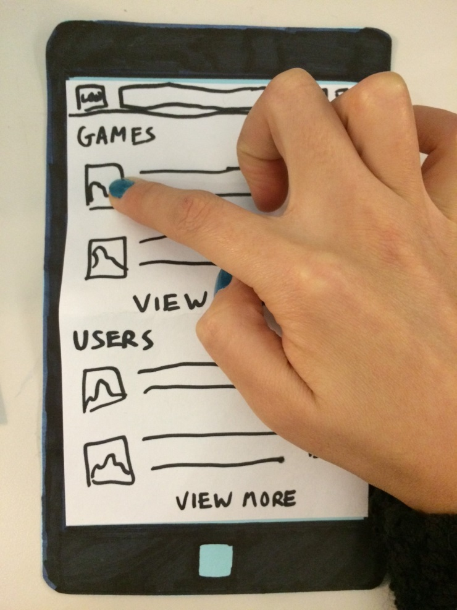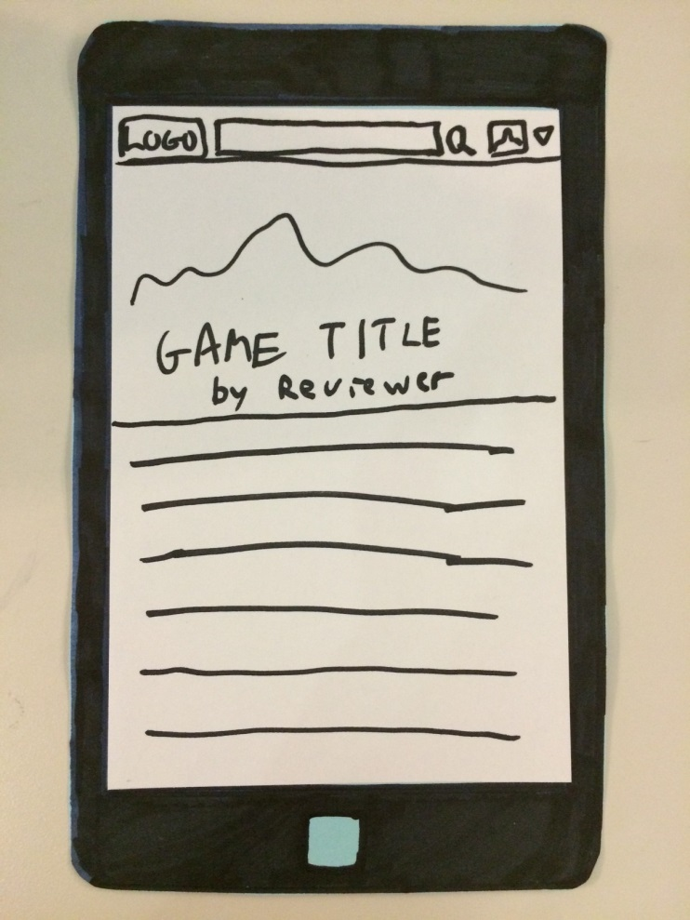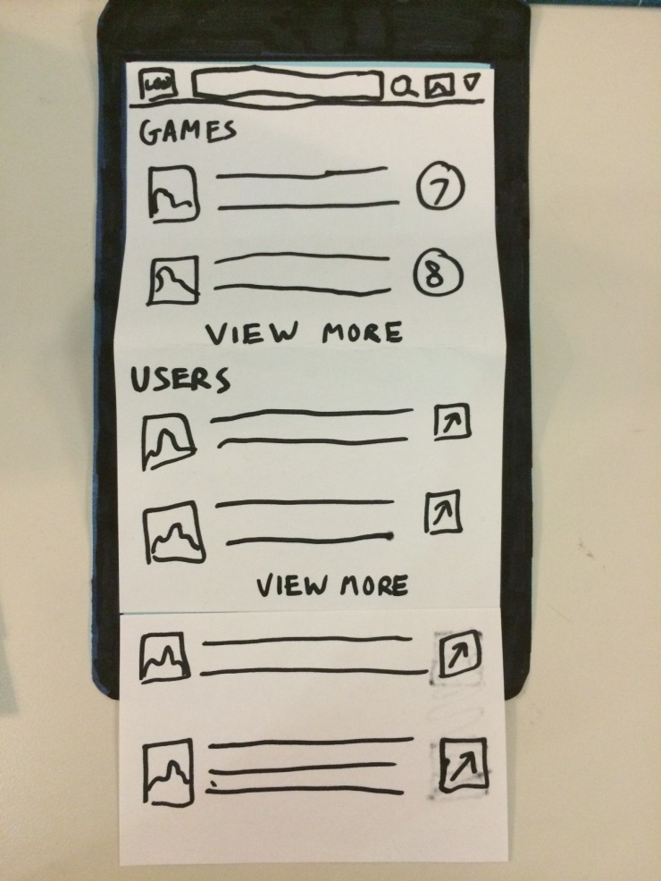

THE

END !

☺

🡺